SAND CHANGE
SILICA SAND OR ZEOBRITE ONLY

- Turn system off.
- Close all valves or plug the return and skimmer. (If system is below water level.)
- Remove small drain plug to drain water out of filter tank.
- a. Top mount valve:
Cut PVC or disconnect hoses and remove valve.
b. Side mounted valve:
Remove top dome or remove bolts from center of tank.
- Cover center standpipe with duct tape.
- Remove sand (use a wet and dry vac or scoop it out) be careful not to break the laterals at the bottom of filter
- Flush tank with water.
- Inspect laterals at bottom of tank for cracks or holes.
- Re-install drain plug.
- Make sure standpipe is completely covered.
- Fill tank ½ way with water.
- Add sand. (Tank should be approx. 2/3 full.)
- Replace valve or top of tank. (Inspect o-ring; lubricate or replace.)
- Replace hoses or repair PVC and remove any plugs installed previously.
- Prime pump on BACKWASH and start pump.
**If using silica sand backwash for ~3-5 minutes, rinse for 45 seconds then put back on filter.
**If using ZEOBRITE backwash for ~4 minutes or until sight glass is clear, rinse THEN leave system off for 5 minutes. Repeat backwash procedure 2 more times until water is running clear from beginning of backwash.

- Check manufacturer instructions for exact amount of sand to be used. If using Zeobrite use ½ the amount.
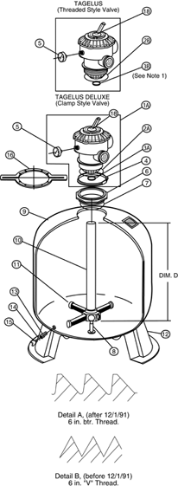
- Change sand / Zeobrite every 3-4 seasons in chlorine pools and 2 seasons in Soft Swim pools.

